**Mice**

**I have left out period 6. So I have 5 time periods.**

**Pictures show Credible Regions (a bit like Confidence Intervals). If the CR intersects the red line, then the result is not significant at 5%.**

**CD19 B220 pos cells**

1. **Does sex matter?**

**Bayes:**

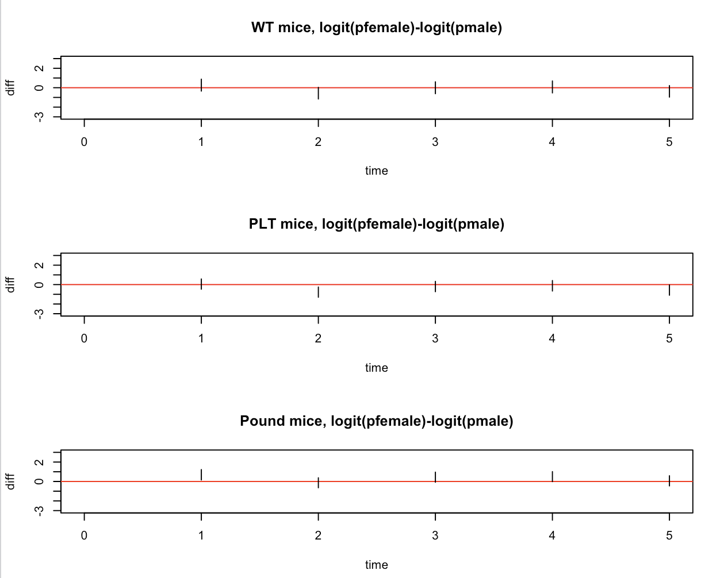

lm:

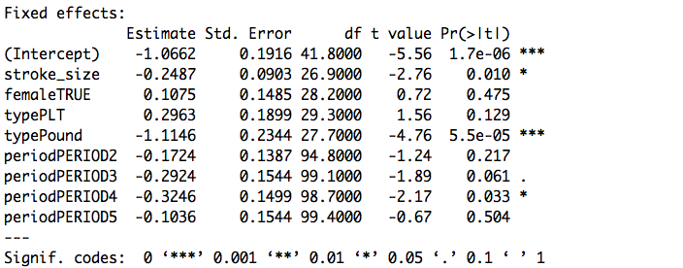

**Conclusion: Sex does not matter.**

AIC is lower for a model without gender. Also AIC does not want stroke_size * type interaction.

1. **Do 3-types of mice react differently over time 0,3,10,17,24 ?**

We compare PLT vs Wt and Pound vs WT, at 5 time points:

**Bayes:**

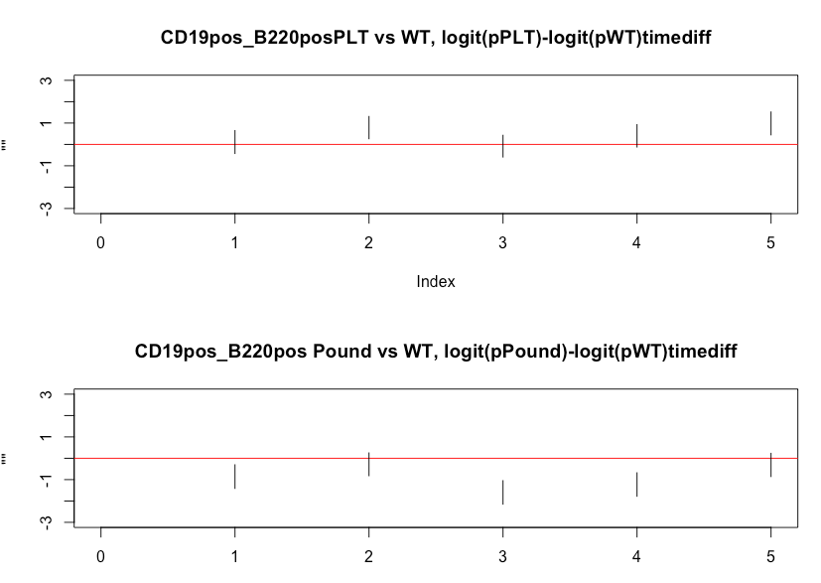

PLT is higher than WT at time 2 and 5.

Pound is lower than WT at time 1, 3 and 4.

**GLM**

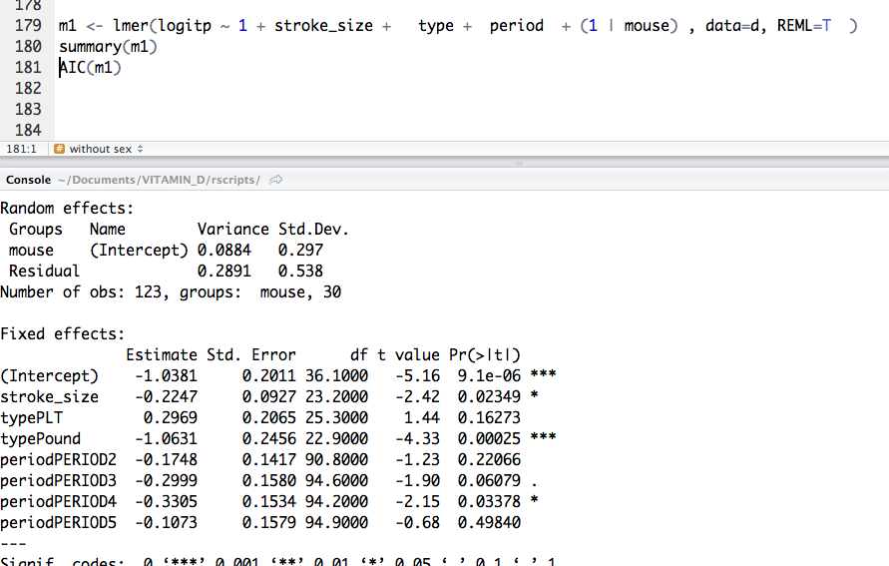

AIC Prefers model without time*type interactions

Pound mice are lower for all periods.

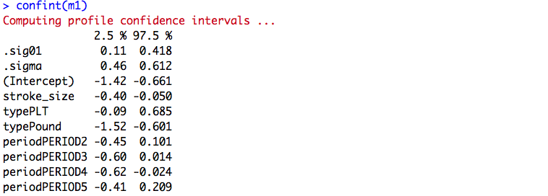

**Pound mice:**

**CI is from -1.52 to -0.601**

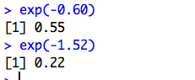

**So the odds ratio of a cell being of type B220… is between**

**[0.22;0.55] odds for Pound / odds for WT**

**Conclusion:**

Pound type mice have a lower proportion of B22pos… cells than WT, though perhaps not at time 2.

PLT mice possibly have more, but not significantly so.

Does the proportion of B220pos cells go down after stroke, and then return to its original proportion?

Bayes: 95% Credible regions:

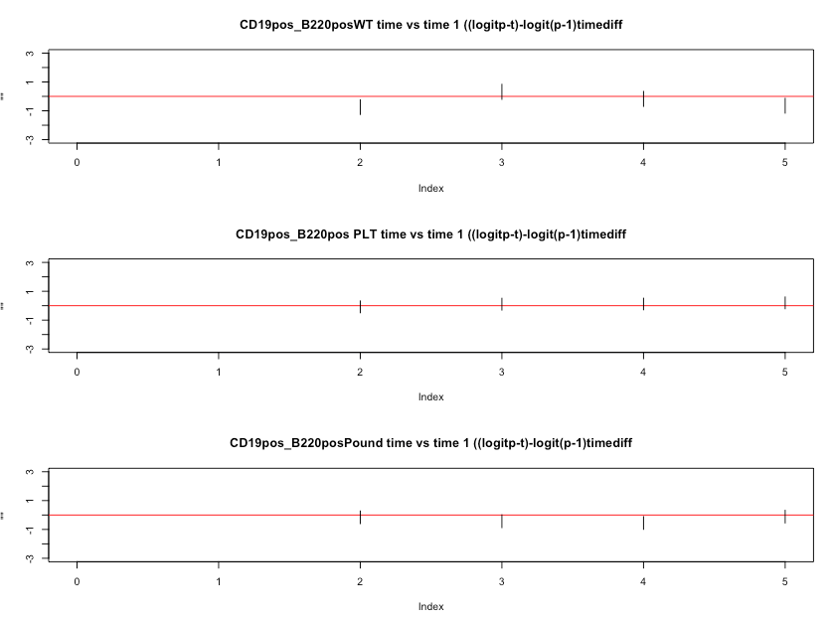

GLM: all period coefficients are not significant.

Bayes: The only CR not including 1 is for WT mice at time 2 (they are lower).

**Conclusion: The proportions cannot be distinguished from those at period 1.**

**To sum up:**

**We cannot detect any difference between the sexes.**

**Pound mice have lower counts than WT, PLT, but not at time 2.**

**No differences between time 1 and subsequent measurements.**

Difference between the sexes:

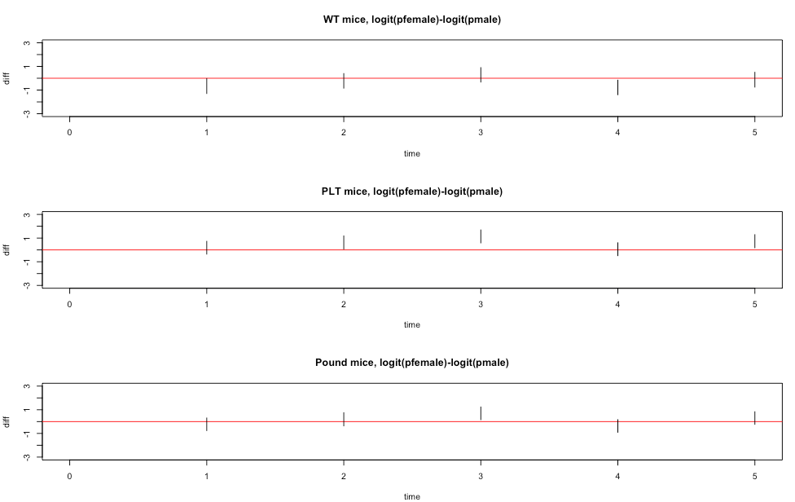

both PLT and pound mice: female higher in time 3.

Seems fairly safe to say not much difference overall

**Difference between the types:**

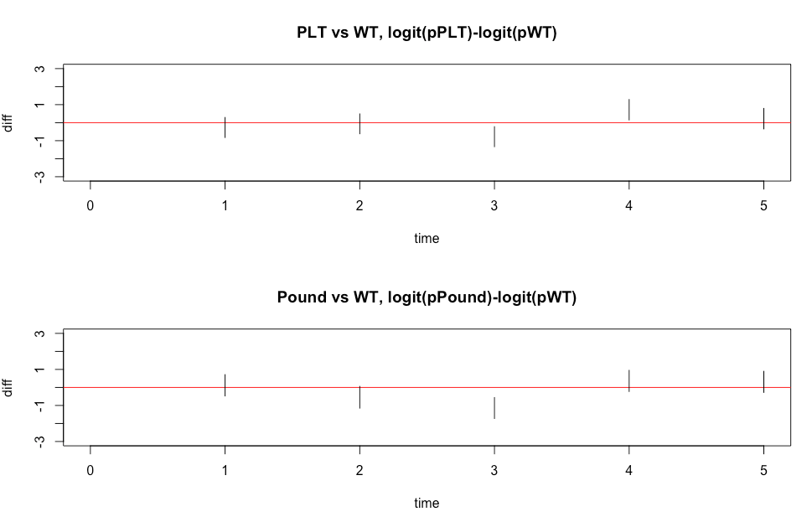

PLT and Pound both lower at time 3, compared to WT.

Difference over time (compared to time 1)

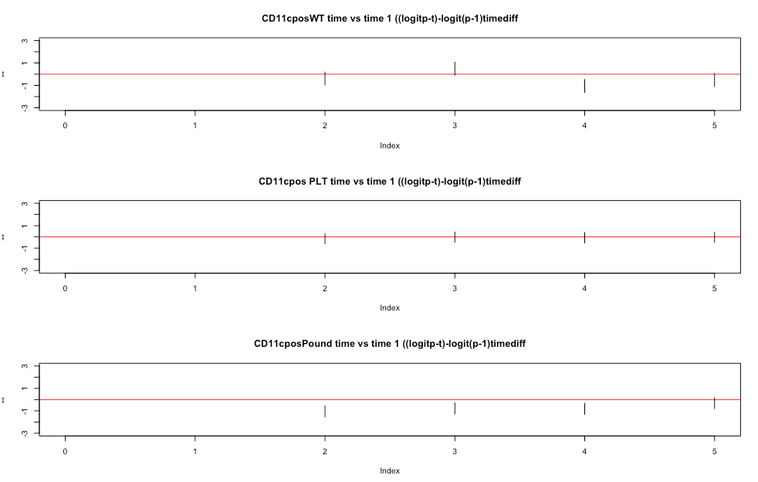

WT mice lower at time 4

Pound mice lower at time 2,3,4 but not at 5.

**Conclusions:**

No evidence of difference between male and female.

Both PLT and Pound lower at time 3, compared to WT

Pound mice lower at time 2,3,4 but not at 5.

**CD11bpos**

Difference between the sexes:

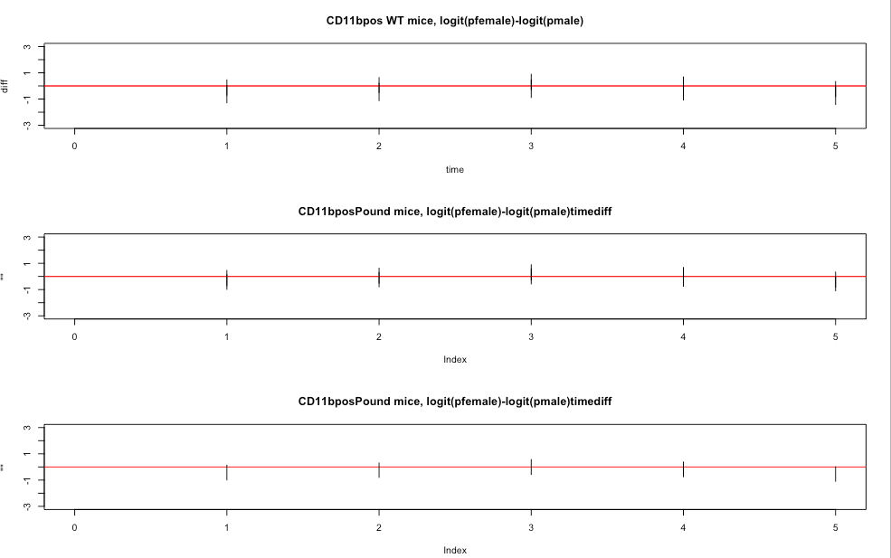

No difference between male and female mice

Differences between types:

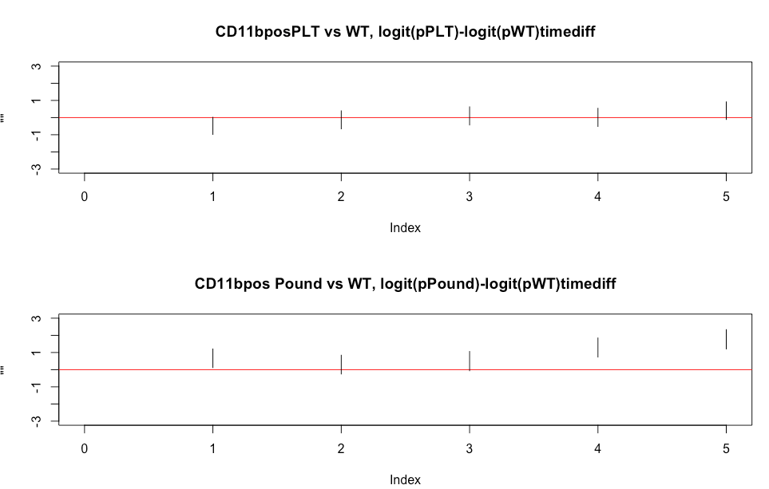

Pound mice are higher than WT at times 1, 4 and 5.

**Difference over time:**

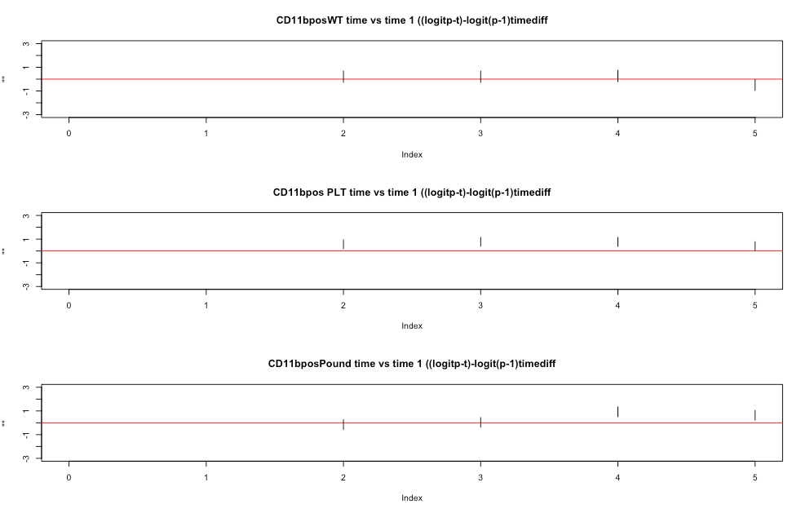

WT mice are similar at all times.

PLT mice are higher at times 2,3,4 compared to time 1

Pound micer are higher at time 4,5, compared to time 1

**Conclusions:**

No differences between the sexes.

Pound mice are higher than WT at times 4 and 5.

WT mice are similar across time

PLT mice are higher at times 2,3,4 compared to time 1

Pound micer are higher at time 4,5, compared to time 1

**mMDCSC**

**Differences between male and female:**

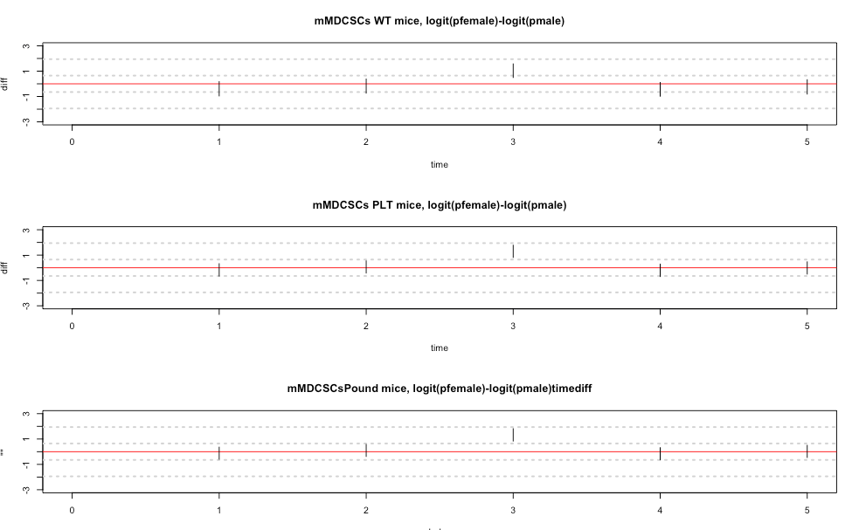

**Female mice are higher at time 3.**

**PLT vs WT and Pound vs WT**

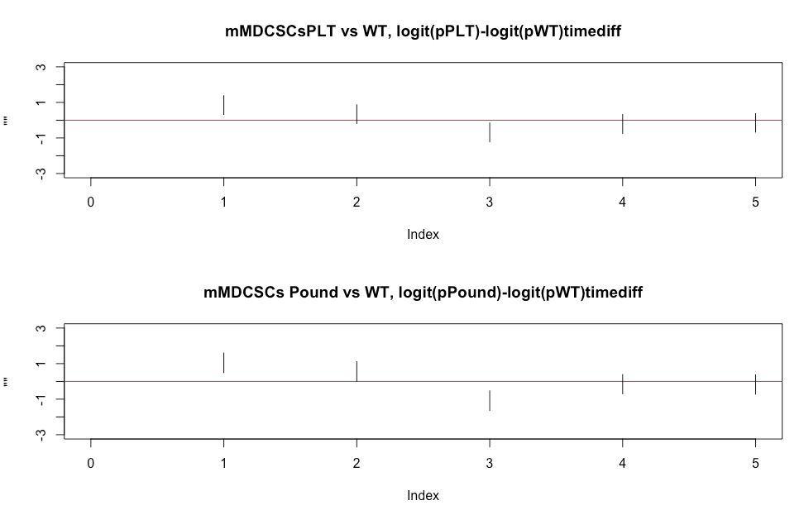

**PLT, Pound both higher at time 1, and lower at time 3.**

**Difference over time:**

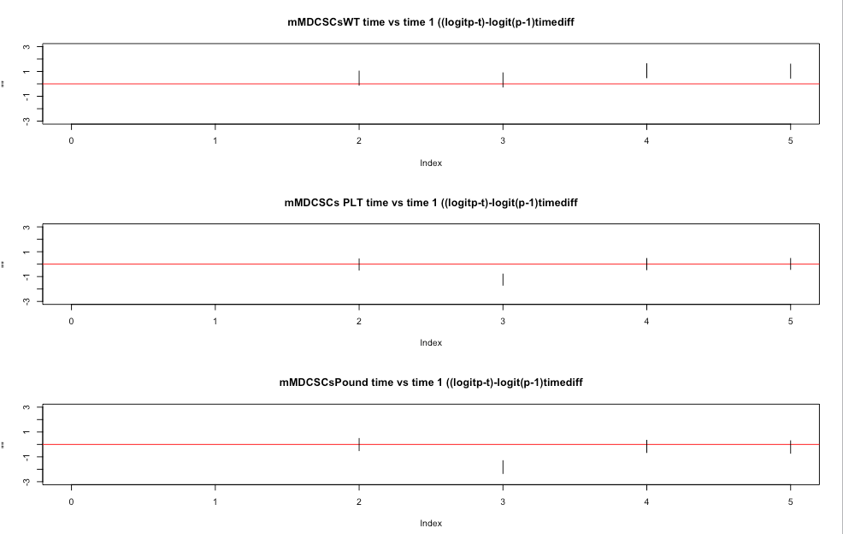

WT mice are higher at time 4 compared to time 1

PLT, Pound mice are lower at time 3 compared to time 1

**Conclusions mMDCSCs:**

**Females higher at time 3**

**PLT, Pound both higher at time 1, and lower at time 3.**

**WT mice are higher at time 4 compared to time 1**

**PLT, Pound mice are lower at time 3 compared to ti**me 1

**mMDCSCs**

**as a proportion of live cells (as opposed to as proportion of CD11b pos cells)**

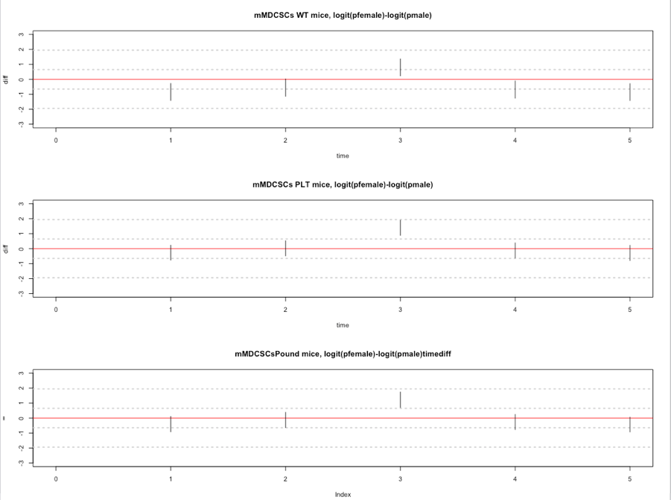

**Female higher at time 3 for all types.**

**Female lower at time 4,5 for WT mice**

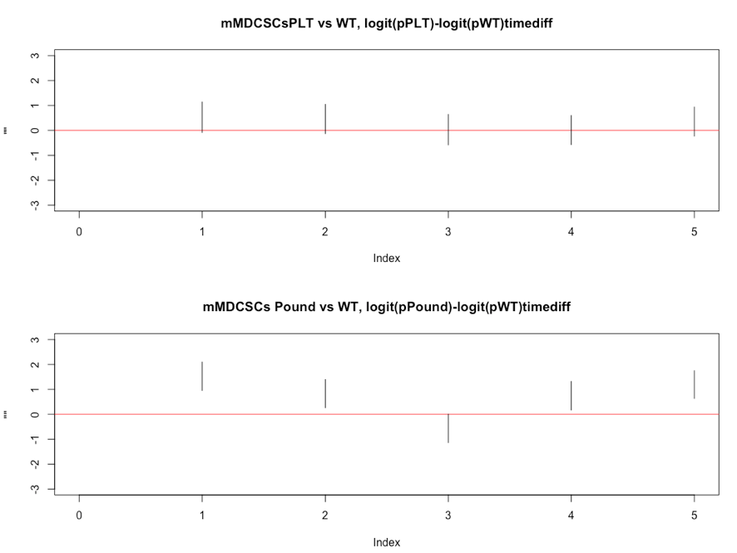

**Pound mice higher than WT mice at all times, borderline at t3.**

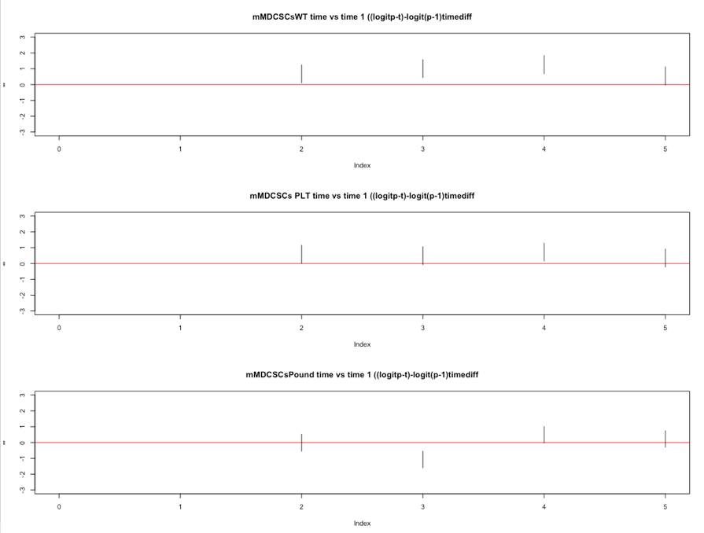

**Comparing to t1:**

**WT: Higher at t2,t3,t4, but back at t1 level at t5**

**PLT: Higher at t4, and back at t1 level at t5**

**Pound: lower at t3, but back at t1 level at t4.**

**gMDSCs**

Difference between sexes:

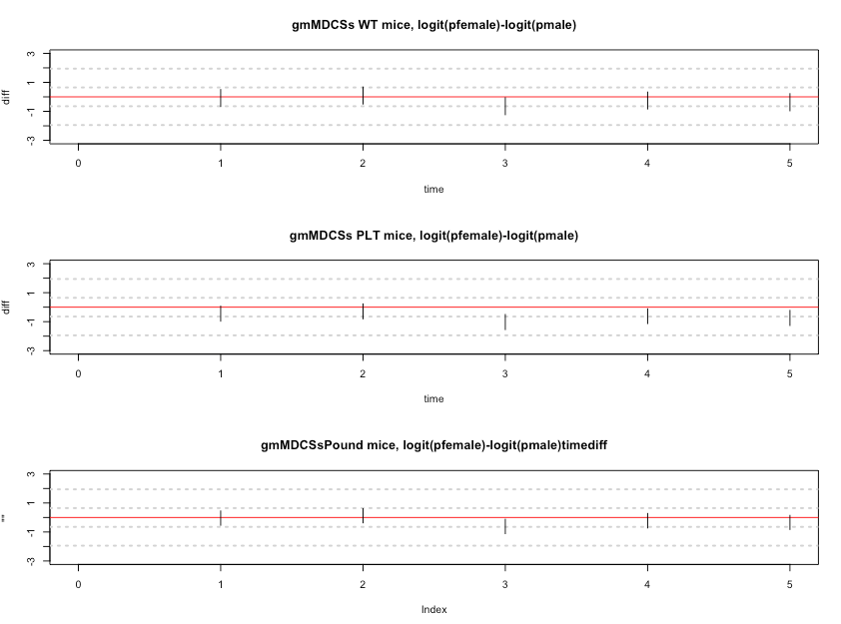

Female PLT mice are lower at time 3,4,5

Female Pound mice are lower at 3 (borderline)

**Differences by type, compared to WT**

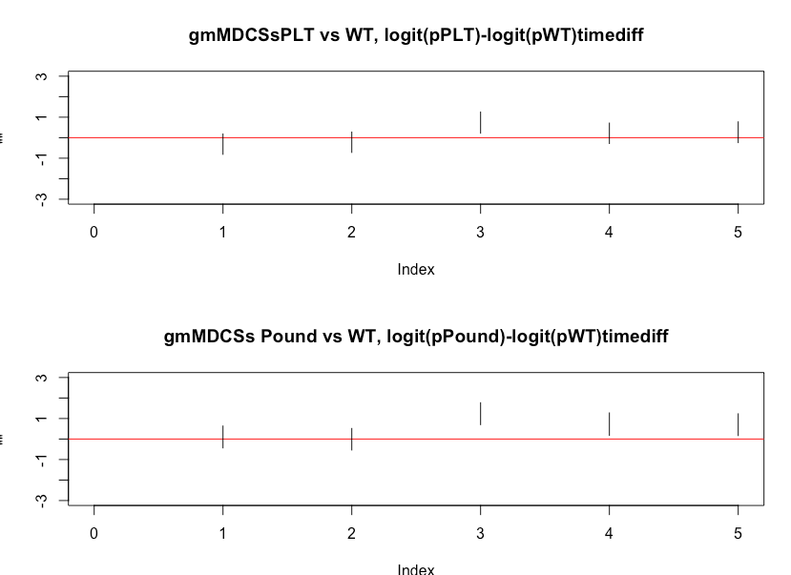

**PLT higher than WT at time 3**

**Pound higher than WT at time 3, 4,5**

**Differences compared to time 1:**

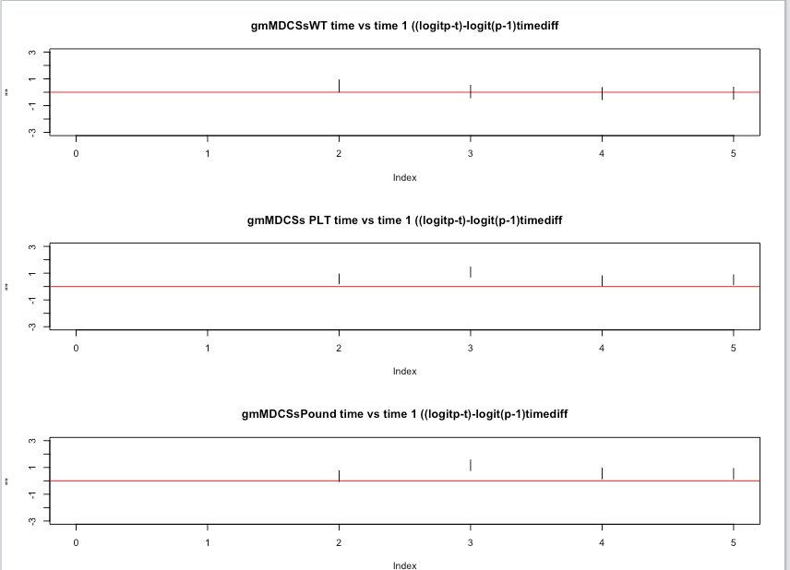

**PLT mice are higher than WT mice at 2,3,4,5**

**Pound mice are higher at 3,4,5**

**Here is a plot at the probability scale, so we can see how it all compares:**

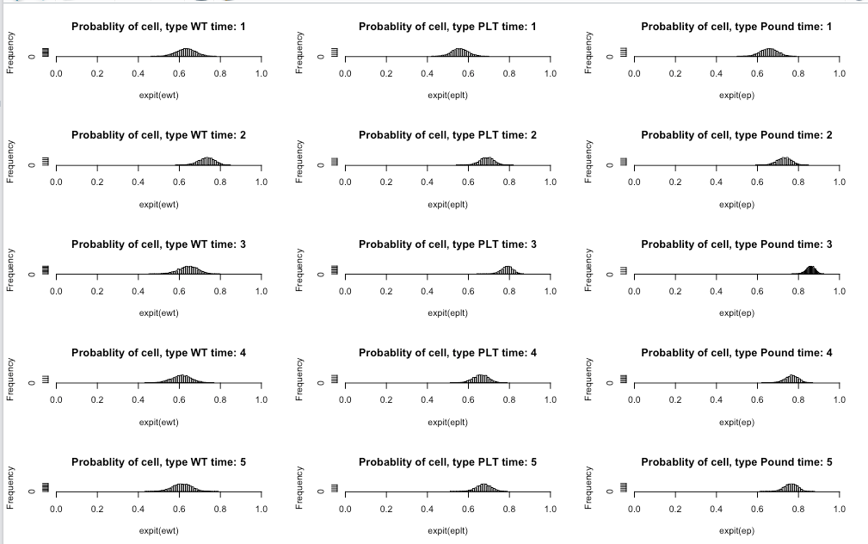

**gMDSCs as proportion of live cells (as opposed to of proportion of Cd11b pos cells)**

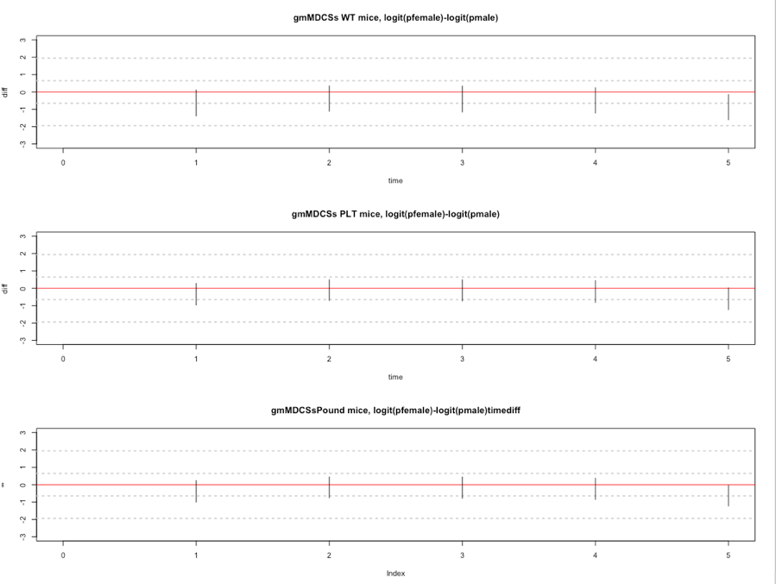

**no difference between male and female mice**

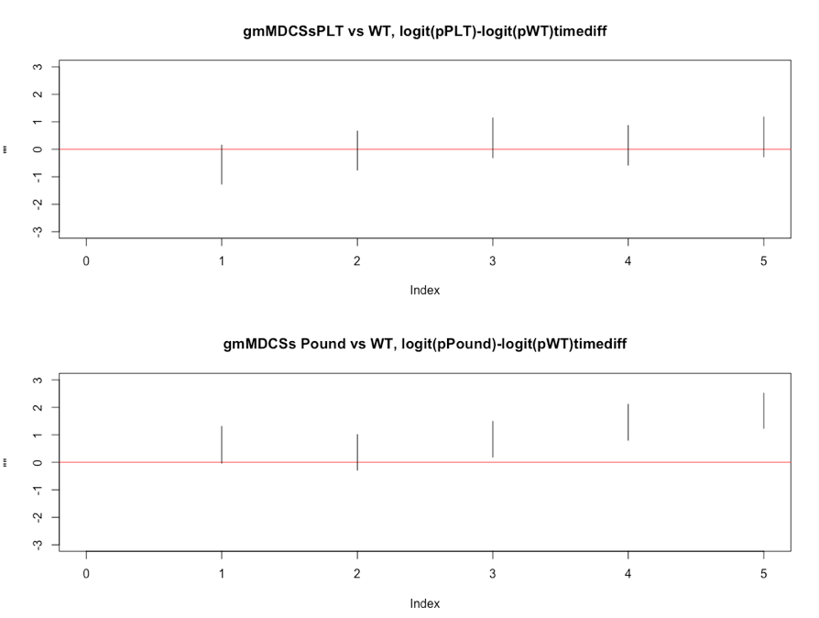

**Pound mice higher at t3,t4,t5 compared to WT**

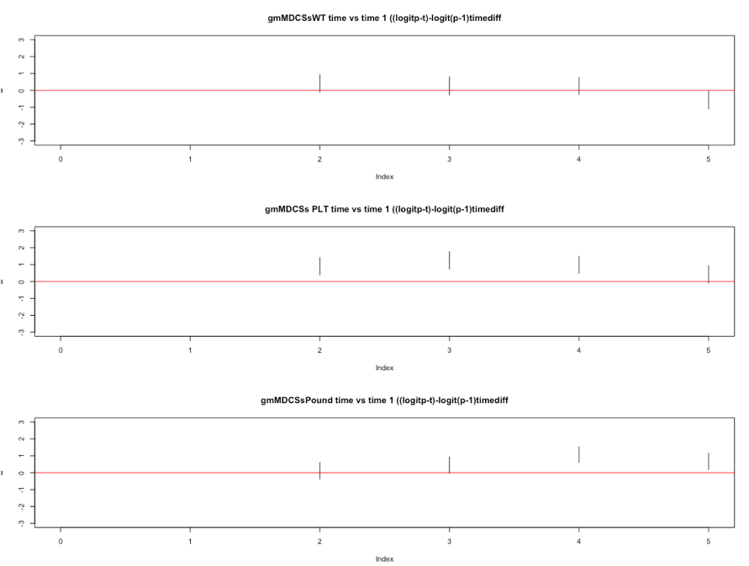

**PLT mice higher at t2,t3,t4 but back at t1 level at t5**

**Pound mice higher at t4, but back at t1 level at t5.**

**intMDSCs**

**Differences by sex:**

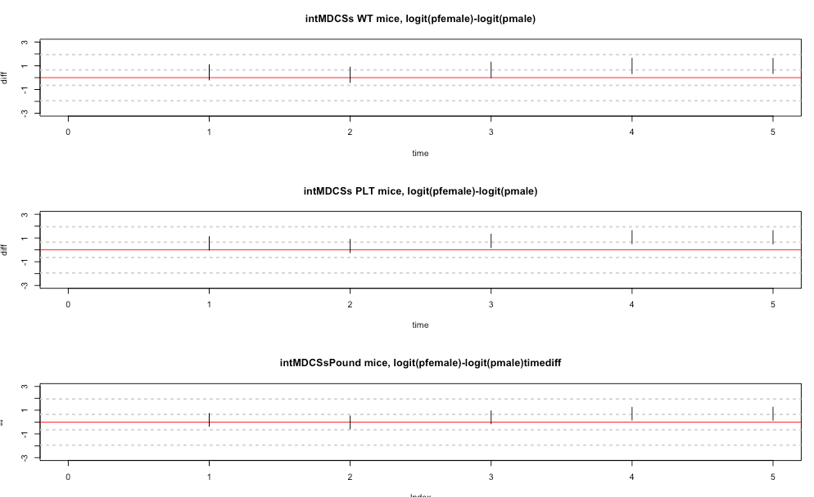

**Female mice are higher for all types at time 4,5**

**PLT mice also higher at time 3.**

**PLT and Pound vs WT**

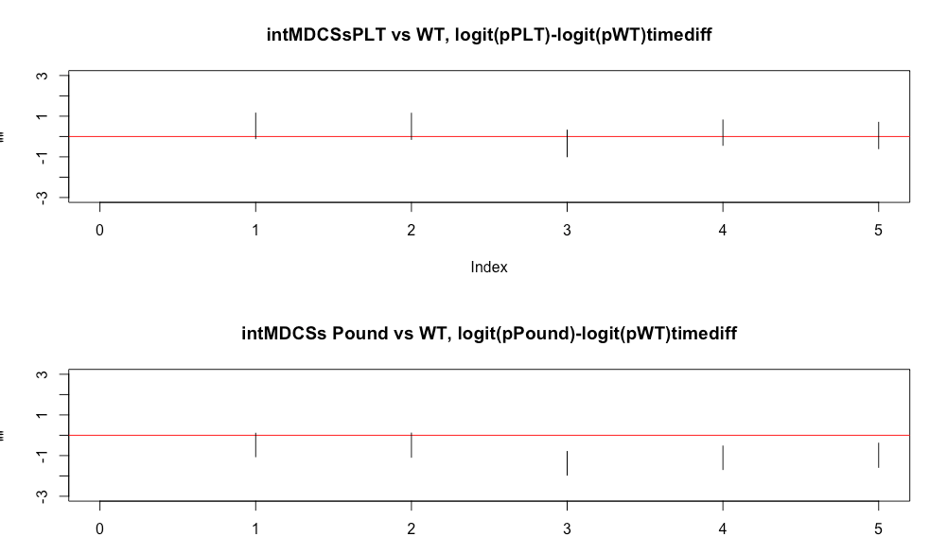

**No difference between PLT and WT**

**Pound mice are lower at time 3,4,5.**

**Compared to time 1**

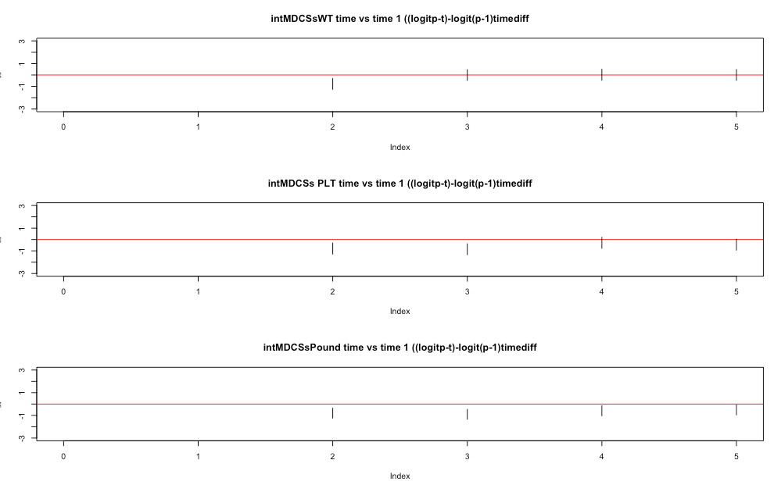

**WT mice are lower at time 2, and then back at t1 level**

**PLT mice are lower at time 2, 3, and then back at t1 level**

**Pound mice are lower at 2,3,4 and then back at t1 level.**

**intMDCSs as proportion of all mice**

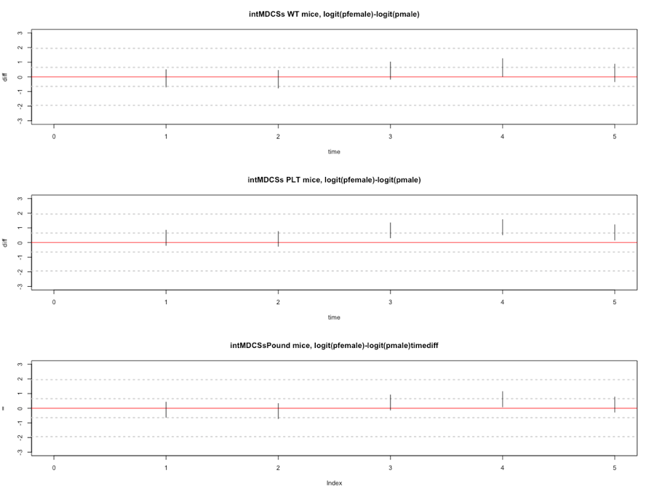

**female PLT mice higher than male at t3,4,5**

**female Pound mice higher at t4 (borderline significant)**

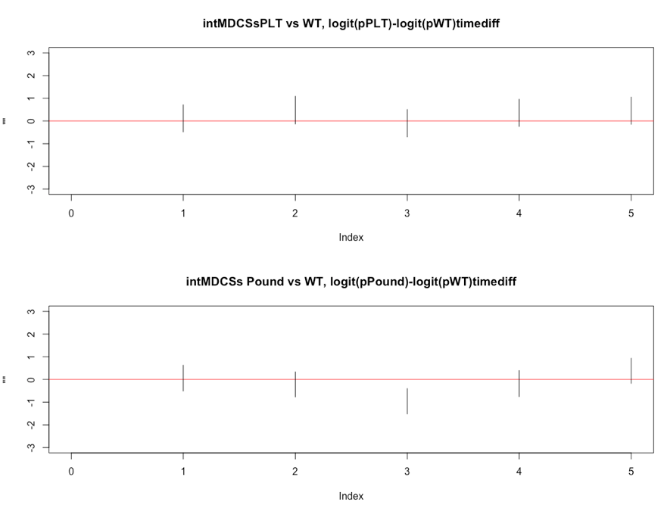

**No differences between PLT and WT**

**Pound lower than wt at t3**

**No differences between PLT and WT**

**Pound lower than wt at t3**

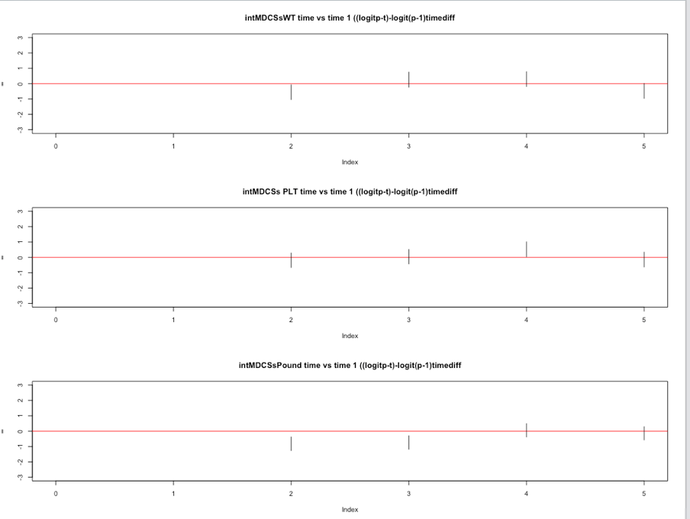

**Pound mice lower at t2,t3 and then back at t1 levels.**